CS 255 System Design Document Jeremy Schultz

UML Diagrams

UML Use Case Diagram
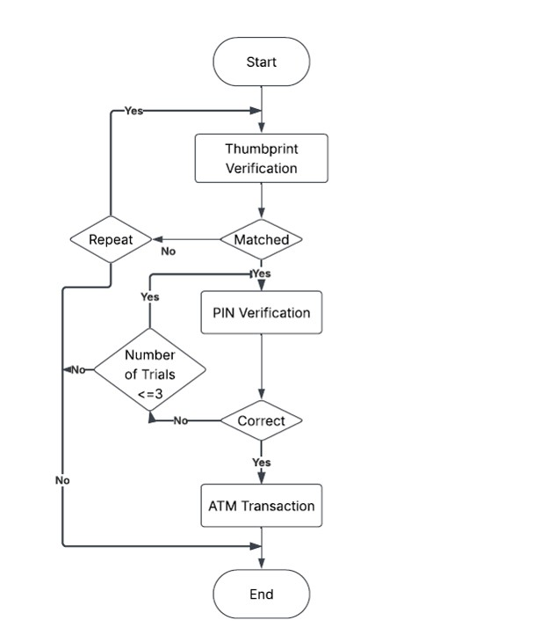

UML Activity Diagrams
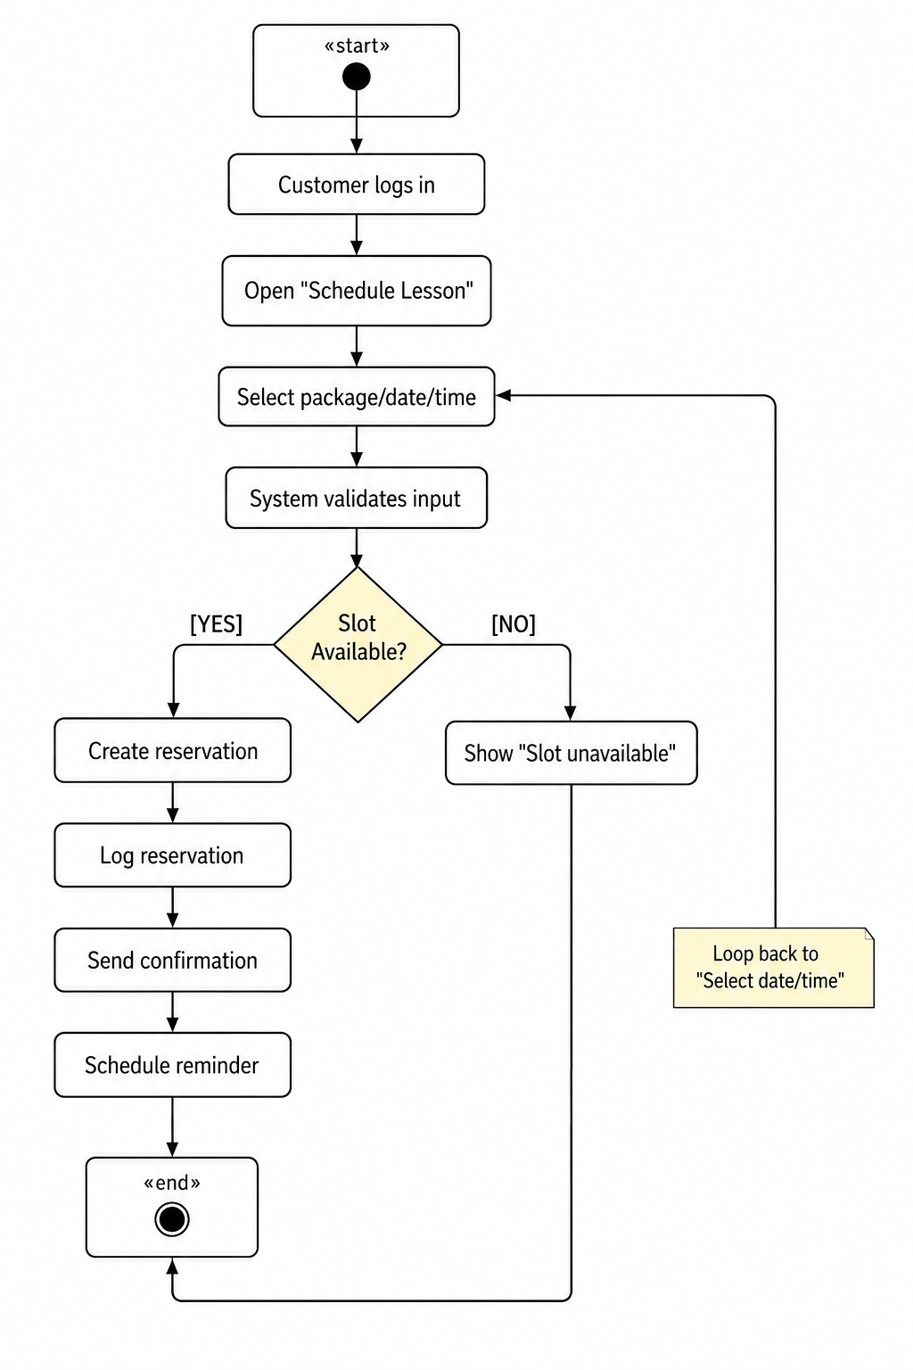

UML Sequence Diagram
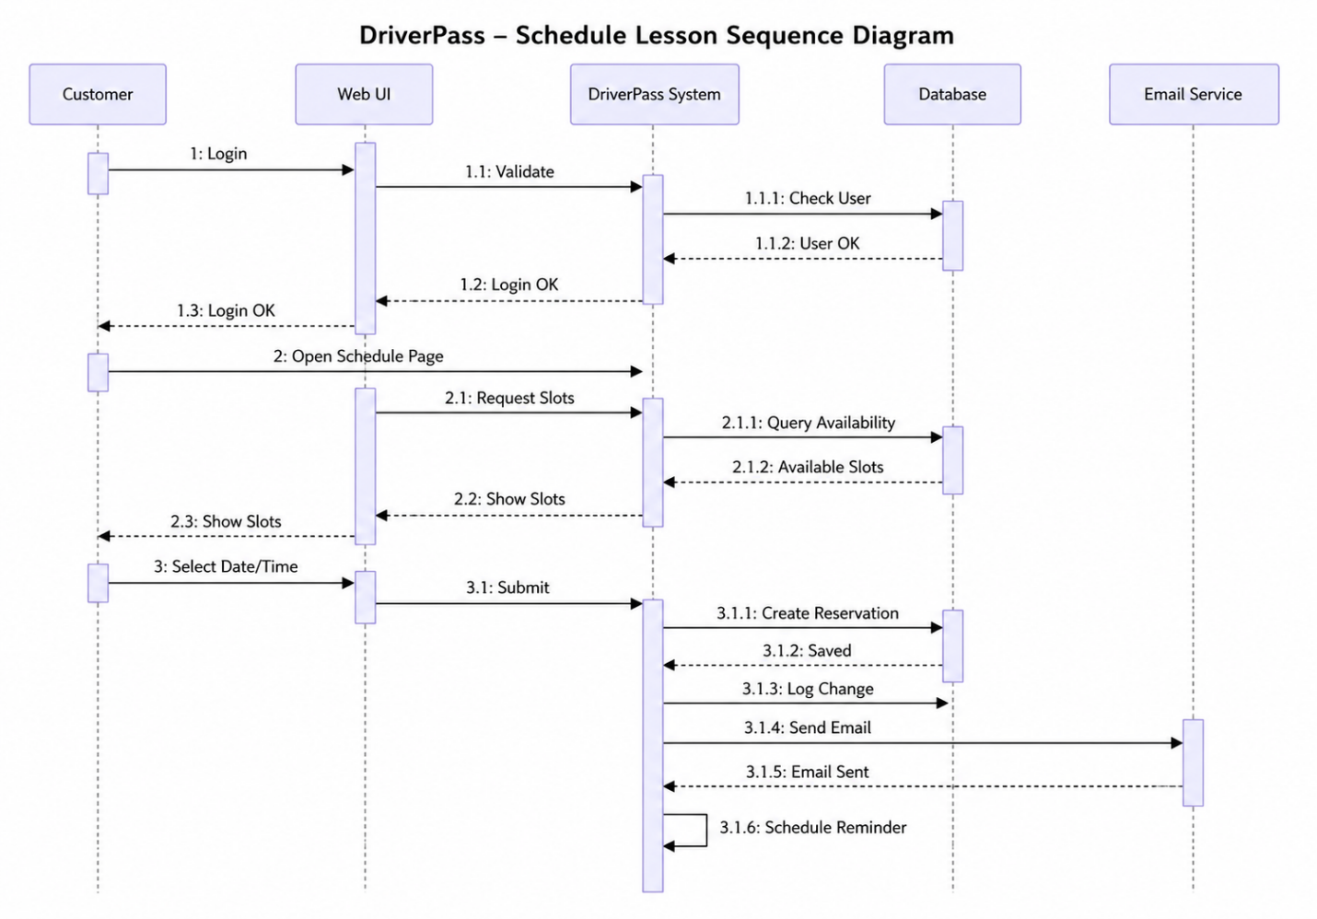

UML Class Diagram
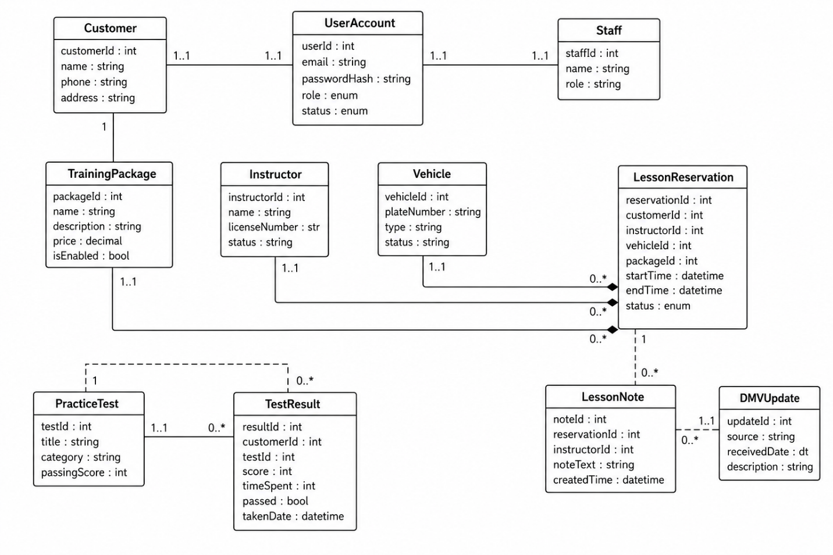

Technical Requirements
Hardware
- Web servers:
  - Cloud-hosted servers capable of handling at least 500 concurrent users.
- Database servers:
  - Managed SQL database instance with automatic backups and scaling.
- Storage:
  - Secure storage for logs, reports, and DMV update files.
Software
- Backend:
  - Web application framework (e.g., Java/.NET/Python) supporting REST APIs and role-based access.
- Database:
  - Relational SQL database for users, reservations, test results, logs, and DMV data.
- Frontend:
  - Browser-based UI built to run on Chrome, Safari, Firefox, and Edge.
- Email and notification services:
  - Service for sending confirmation emails and automated reminders.
- Scheduler:
  - Background job scheduler for reminders and DMV sync tasks.
Tools
- CASE tool:
  - Lucidchart for UML diagrams and Gantt chart.
- Development tools:
  - IDEs, version control (Git), issue tracking.
- Monitoring tools:
  - Application and database monitoring, log aggregation.
Infrastructure
- Cloud hosting:
  - Web-based, cloud environment with auto-scaling and secure backups.
- Network:
  - HTTPS-only connections for all client–server communication.
- Security:
  - Encrypted passwords, database encryption for sensitive data, account lockout after failed attempts, RBAC for staff/admin.
- Integration:
  - API connection to DMV systems for rules and sample questions.
- Availability and maintenance:
  - 24/7 availability with maintenance during off-peak hours.

